Exploring and Preparing Data
Estimated time needed: 70 minutes
In this assignment, we will predict if the Falcon 9 first stage will land successfully. SpaceX advertises Falcon 9 rocket launches on its website with a cost of 62 million dollars; other providers cost upward of 165 million dollars each, much of the savings is due to the fact that SpaceX can reuse the first stage.
In this lab, you will perform Exploratory Data Analysis and Feature Engineering.
Falcon 9 first stage will land successfully
Most unsuccessful landings are planned. Space X performs a controlled landing in the oceans.
Objectives
Perform exploratory Data Analysis and Feature Engineering using Pandas and Matplotlib
- Exploratory Data Analysis
- Preparing Data Feature Engineering
Import Libraries and Define Auxiliary Functions
We will import the following libraries the lab
import piplite
await piplite.install(['numpy'])
await piplite.install(['pandas'])
await piplite.install(['seaborn'])
Then
# pandas is a software library written for the Python programming language for data manipulation and analysis.
import pandas as pd
#NumPy is a library for the Python programming language, adding support for large, multi-dimensional arrays and matrices, along with a large collection of high-level mathematical functions to operate on these arrays
import numpy as np
# Matplotlib is a plotting library for python and pyplot gives us a MatLab like plotting framework. We will use this in our plotter function to plot data.
import matplotlib.pyplot as plt
#Seaborn is a Python data visualization library based on matplotlib. It provides a high-level interface for drawing attractive and informative statistical graphics
import seaborn as sns
Exploratory Data Analysis
First, let's read the SpaceX dataset into a Pandas dataframe and print its summary
from js import fetch
import io

URL = "https://cf-courses-data.s3.us.cloud-object-storage.appdomain.cloud/IBM-DS0321EN-SkillsNetwork/datasets/dataset_part_2.csv"
resp = await fetch(URL)
dataset_part_2_csv = io.BytesIO((await resp.arrayBuffer()).to_py())
df=pd.read_csv(dataset_part_2_csv)
df.head(5)
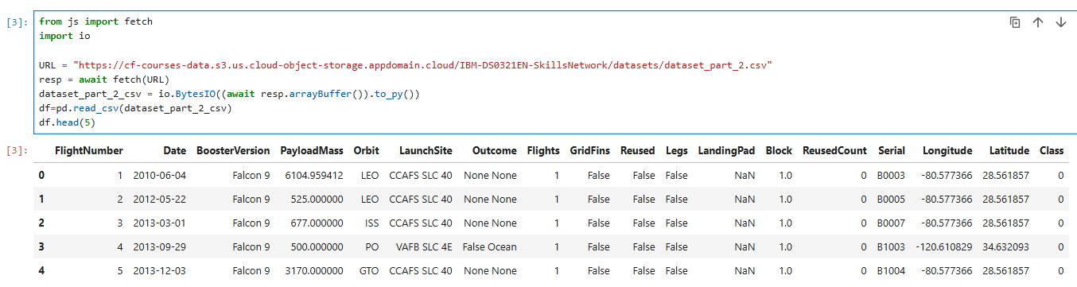
First, let's try to see how the FlightNumber (indicating the continuous launch attempts.) and Payload variables would affect the launch outcome.
We can plot out the FlightNumber vs. PayloadMassand overlay the outcome of the launch. We see that as the flight number increases, the first stage is more likely to land successfully. The payload mass also appears to be a factor; even with more massive payloads, the first stage often returns successfully.
sns.catplot(y="PayloadMass", x="FlightNumber", hue="Class", data=df, aspect = 5)
plt.xlabel("Flight Number",fontsize=20)
plt.ylabel("Pay load Mass (kg)",fontsize=20)
plt.show()
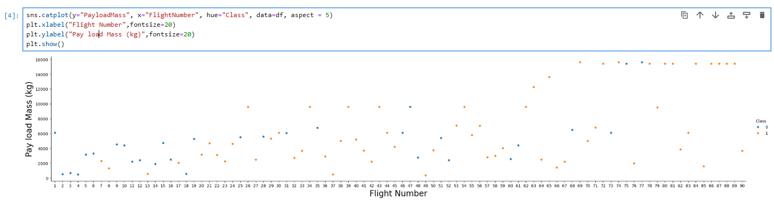
Next, let's drill down to each site visualize its detailed launch records.
TASK 1: Visualize the relationship between Flight Number and Launch Site
Use the function catplot to plot FlightNumber vs LaunchSite, set the parameter x parameter to FlightNumber,set the y to Launch Site and set the parameter hue to 'class'
# Plot a scatter point chart with x axis to be Flight Number and y axis to be the launch site, and hue to be the class value
sns.catplot(y='LaunchSite', x='FlightNumber', hue='Class', kind='strip', data=df, aspect = 5)
plt.xlabel('FlightNumber', fontsize=20)
plt.ylabel('LaunchSite', fontsize=20)
plt.show()
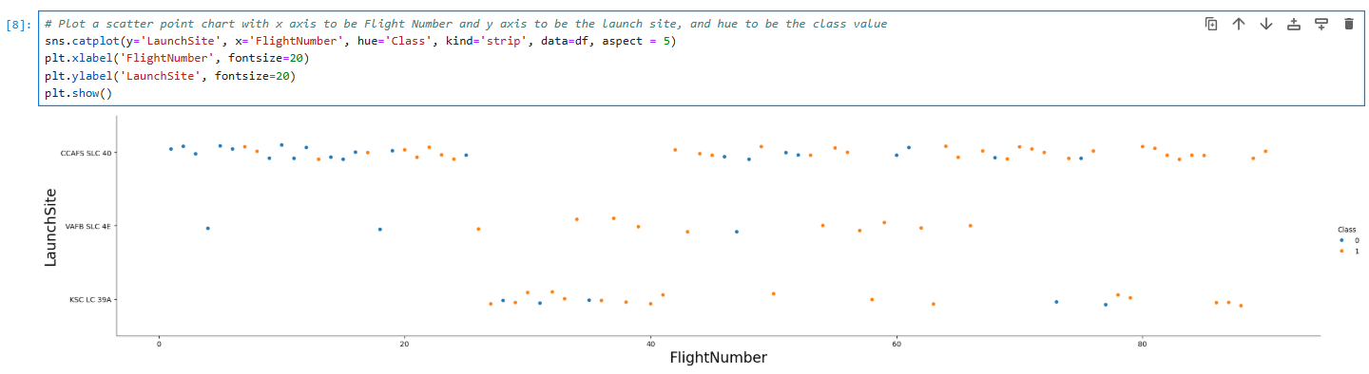
Now try to explain the patterns you found in the Flight Number vs. Launch Site scatter point plots.
TASK 2: Visualize the relationship between Payload Mass and Launch Site
We also want to observe if there is any relationship between launch sites and their payload mass.
# Plot a scatter point chart with x axis to be Pay Load Mass (kg) and y axis to be the launch site, and hue to be the class value
sns.catplot(y='LaunchSite', x='PayloadMass', hue='Class', kind='strip', data=df, aspect = 5)
plt.xlabel('PayloadMass', fontsize=20)
plt.ylabel('LaunchSite', fontsize=20)
plt.show()
Now if you observe Payload Mass Vs. Launch Site scatter point chart you will find for the VAFB-SLC launchsite there are no rockets launched for heavypayload mass(greater than 10000).
TASK 3: Visualize the relationship between success rate of each orbit type
Next, we want to visually check if there are any relationship between success rate and orbit type.
Let's create a bar chart for the success rate of each orbit
# HINT use groupby method on Orbit column and get the mean of Class column
# Groupby and calculate mean of Success Rate
orbit_success = df.groupby('Orbit')['Class'].mean().reset_index()
orbit_success.rename(columns={'Class': 'SuccessRate'}, inplace=True)

# Plot the bar chart
sns.barplot(data=orbit_success, x='Orbit', y='SuccessRate')
plt.xticks(rotation=45)
plt.xlabel('Orbit Type', fontsize=14)
plt.ylabel('Success Rate', fontsize=14)
plt.title('Success Rate by Orbit Type', fontsize=20)
plt.show
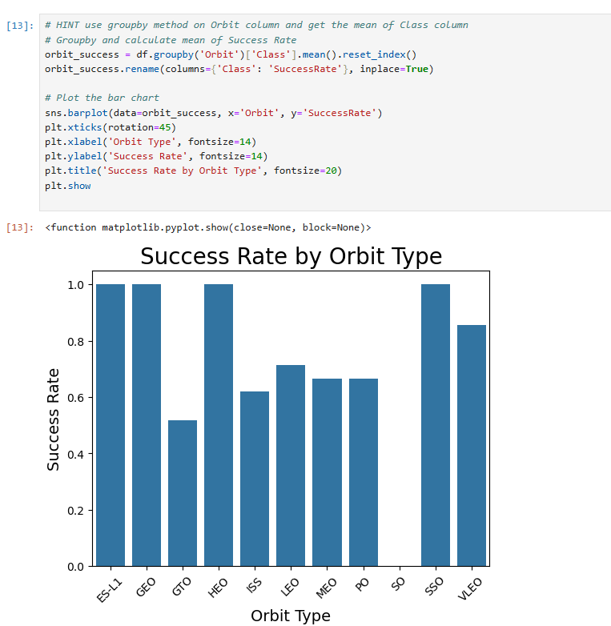
Analyze the plotted bar chart to identify which orbits have the highest success rates.
# ES-L1, GEO, HEO and SSO all have the highest success rates.
TASK 4: Visualize the relationship between FlightNumber and Orbit type
For each orbit, we want to see if there is any relationship between FlightNumber and Orbit type.
# Plot a scatter point chart with x axis to be FlightNumber and y axis to be the Orbit, and hue to be the class value
sns.catplot(y='Orbit', x='FlightNumber', hue='Class', kind='strip', data=df, aspect = 5)
plt.xlabel('FlightNumber', fontsize=20)
plt.ylabel('Orbit', fontsize=20)
plt.show()
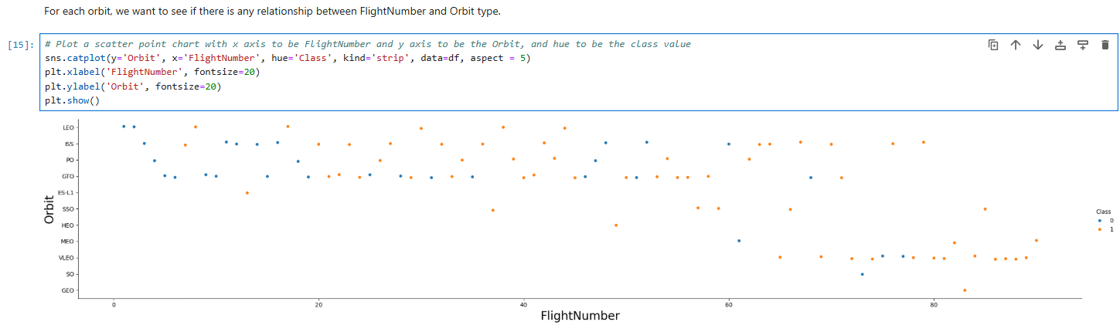
TASK 5: Visualize the relationship between Payload Mass and Orbit type
Similarly, we can plot the Payload Mass vs. Orbit scatter point charts to reveal the relationship between Payload Mass and Orbit type
# Plot a scatter point chart with x axis to be Payload Mass and y axis to be the Orbit, and hue to be the class value
sns.catplot(y='Orbit', x='PayloadMass', hue='Class', kind='strip', data=df, aspect = 5)
plt.xlabel('PayloadMass', fontsize=20)
plt.ylabel('Orbit', fontsize=20)
plt.show()
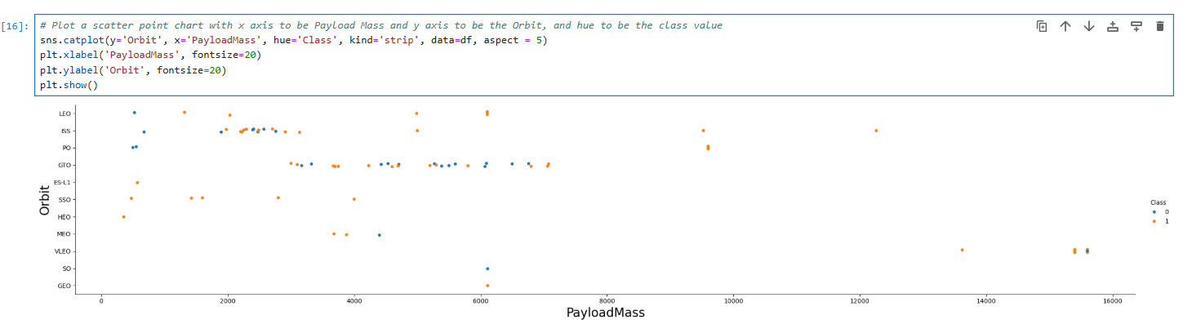
With heavy payloads the successful landing or positive landing rate are more for Polar,LEO and ISS.
However, for GTO, it's difficult to distinguish between successful and unsuccessful landings as both outcomes are present.
TASK 6: Visualize the launch success yearly trend
You can plot a line chart with x axis to be Year and y axis to be average success rate, to get the average launch success trend.
The function will help you get the year from the date:
# A function to Extract years from the date
year=[]
def Extract_year():
for i in df["Date"]:
year.append(i.split("-")[0])
return year
Extract_year()
df['Date'] = year
df.head()
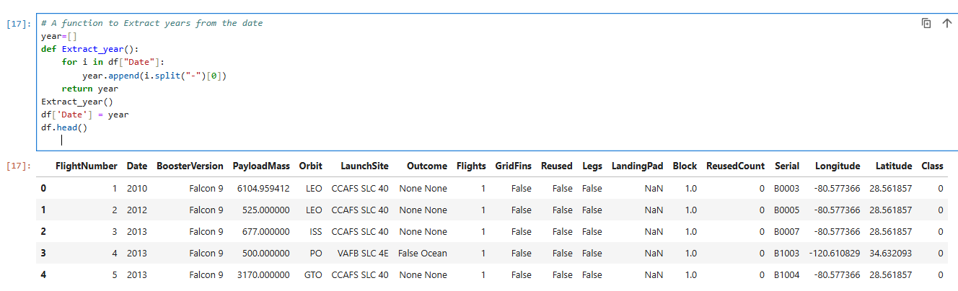
Then
# Plot a line chart with x axis to be the extracted year and y axis to be the success rate
# Extract year
df['Year'] = df['Date'].apply(lambda x: x.split('-')[0])

# Calculate average success rate
yearly_success = df.groupby('Year')['Class'].mean().reset_index()
yearly_success.rename(columns={'Class': 'SuccessRate'}, inplace=True)
then
sns.lineplot(data=yearly_success, x='Year', y='SuccessRate')
plt.xlabel('Year', fontsize=14)
plt.ylabel('Average Success Rate', fontsize=14)
plt.title('Launch Success Trend by Year', fontsize=16)
plt.xticks(rotation=45)
plt.show()
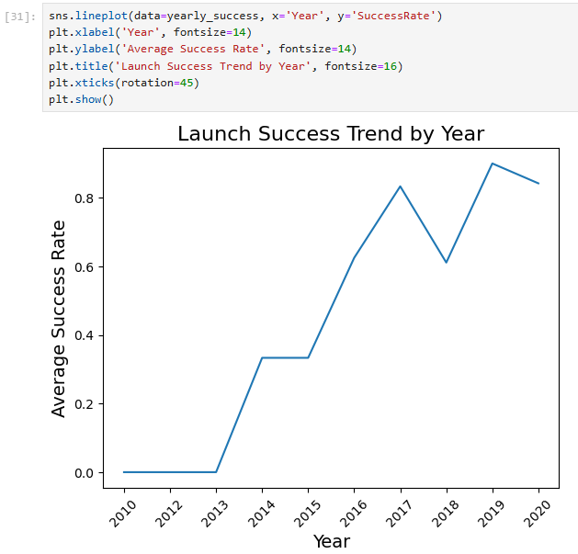
you can observe that the success rate since 2013 kept increasing till 2020
Features Engineering
By now, you should obtain some preliminary insights about how each important variable would affect the success rate, we will select the features that will be used in success prediction in the future module.
features = df[['FlightNumber', 'PayloadMass', 'Orbit', 'LaunchSite', 'Flights', 'GridFins', 'Reused', 'Legs', 'LandingPad', 'Block', 'ReusedCount', 'Serial']]
features.head()
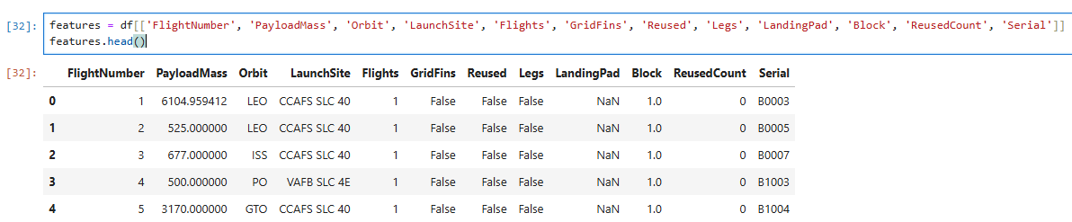
TASK 7: Create dummy variables to categorical columns
Use the function get_dummies and features dataframe to apply OneHotEncoder to the column Orbits, LaunchSite, LandingPad, and Serial. Assign the value to the variable features_one_hot, display the results using the method head. Your result dataframe must include all features including the encoded ones.
# HINT: Use get_dummies() function on the categorical columns
# Apply one-hot encoding
features_one_hot = pd.get_dummies(
features,
columns=['Orbit', 'LaunchSite', 'LandingPad', 'Serial'],
drop_first=False
)

# Display the result
features_one_hot.head()
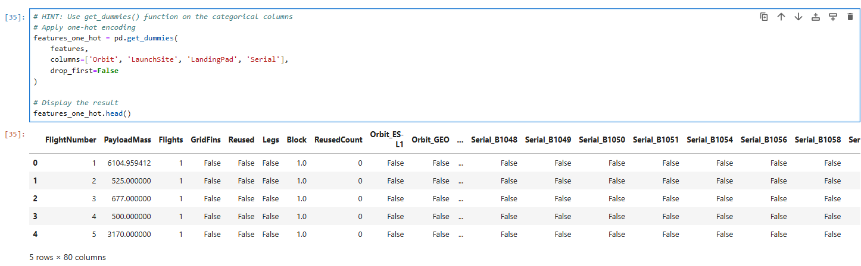
TASK 8: Cast all numeric columns to float64
Now that our features_one_hot dataframe only contains numbers, cast the entire dataframe to variable type float64
# HINT: use astype function
features_one_hot=features_one_hot.astype('float64')

